BLOGS ON HUMAN RIGHT VIOLATIONS
TASK 1:
Have a quick look at the titles of the following blogs
and read the first paragraph to choose one of the topics.
 | 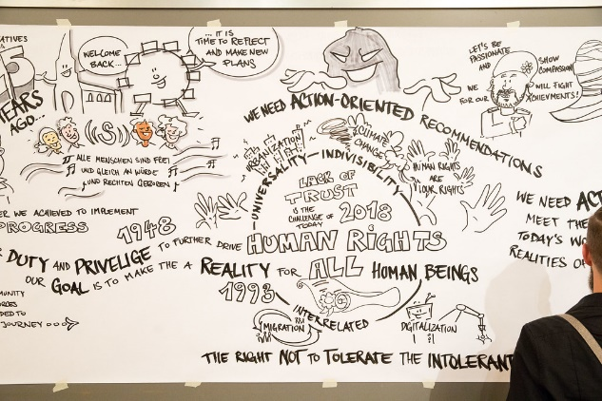  (c) photonews.at/Anna Rauchenberger (https://www.flickr.com/photos/minoritenplatz8/28444210778)  https://blog.amnestyusa.org/
 |  | https://cpcs.wp.st-andrews.ac.uk/people/student-reflective-blogs/
 | https://world-education-blog.org/category/conflict/
 |  | https://www.amnesty.org.uk/blogs
 | https://www.defendingwomen-defendingrights.org/category/blog/
 |  | https://www.humanrightscareers.com/issues/human-rights-blogs/
 | https://www.sipri.org/commentary/blog
 |  | https://www.unicef.org/blog


(C) Christian Schnettelker: https://www.manoftaste.de (https://www.flickr.com/photos/96913861@N04/14045819341)

TASK 2:
- Find words and phrases
  - which are useful for talking about your specific topic
  - which you might use for writing your own blog entry later:
examples:
- From my point of view
- XY should be taken into account
- Another issue raised by
- I believe that when it comes to
- you can … and here is how
- Add them to our vocabulary task cards.
- Now focus on the content of the blog entry:
Take notes and prepare a short presentation.
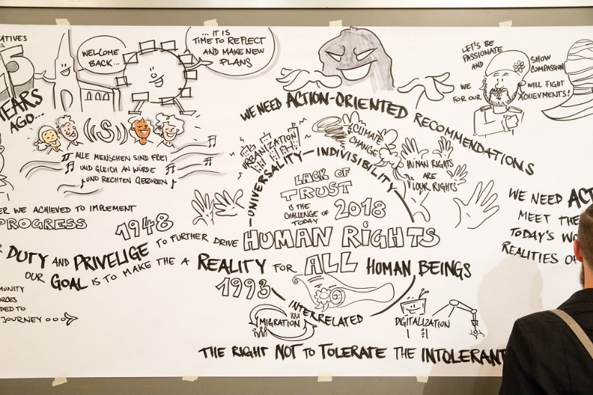
(c) photonews.at/Anna Rauchenberger (https://www.flickr.com/photos/minoritenplatz8/28444210778)

