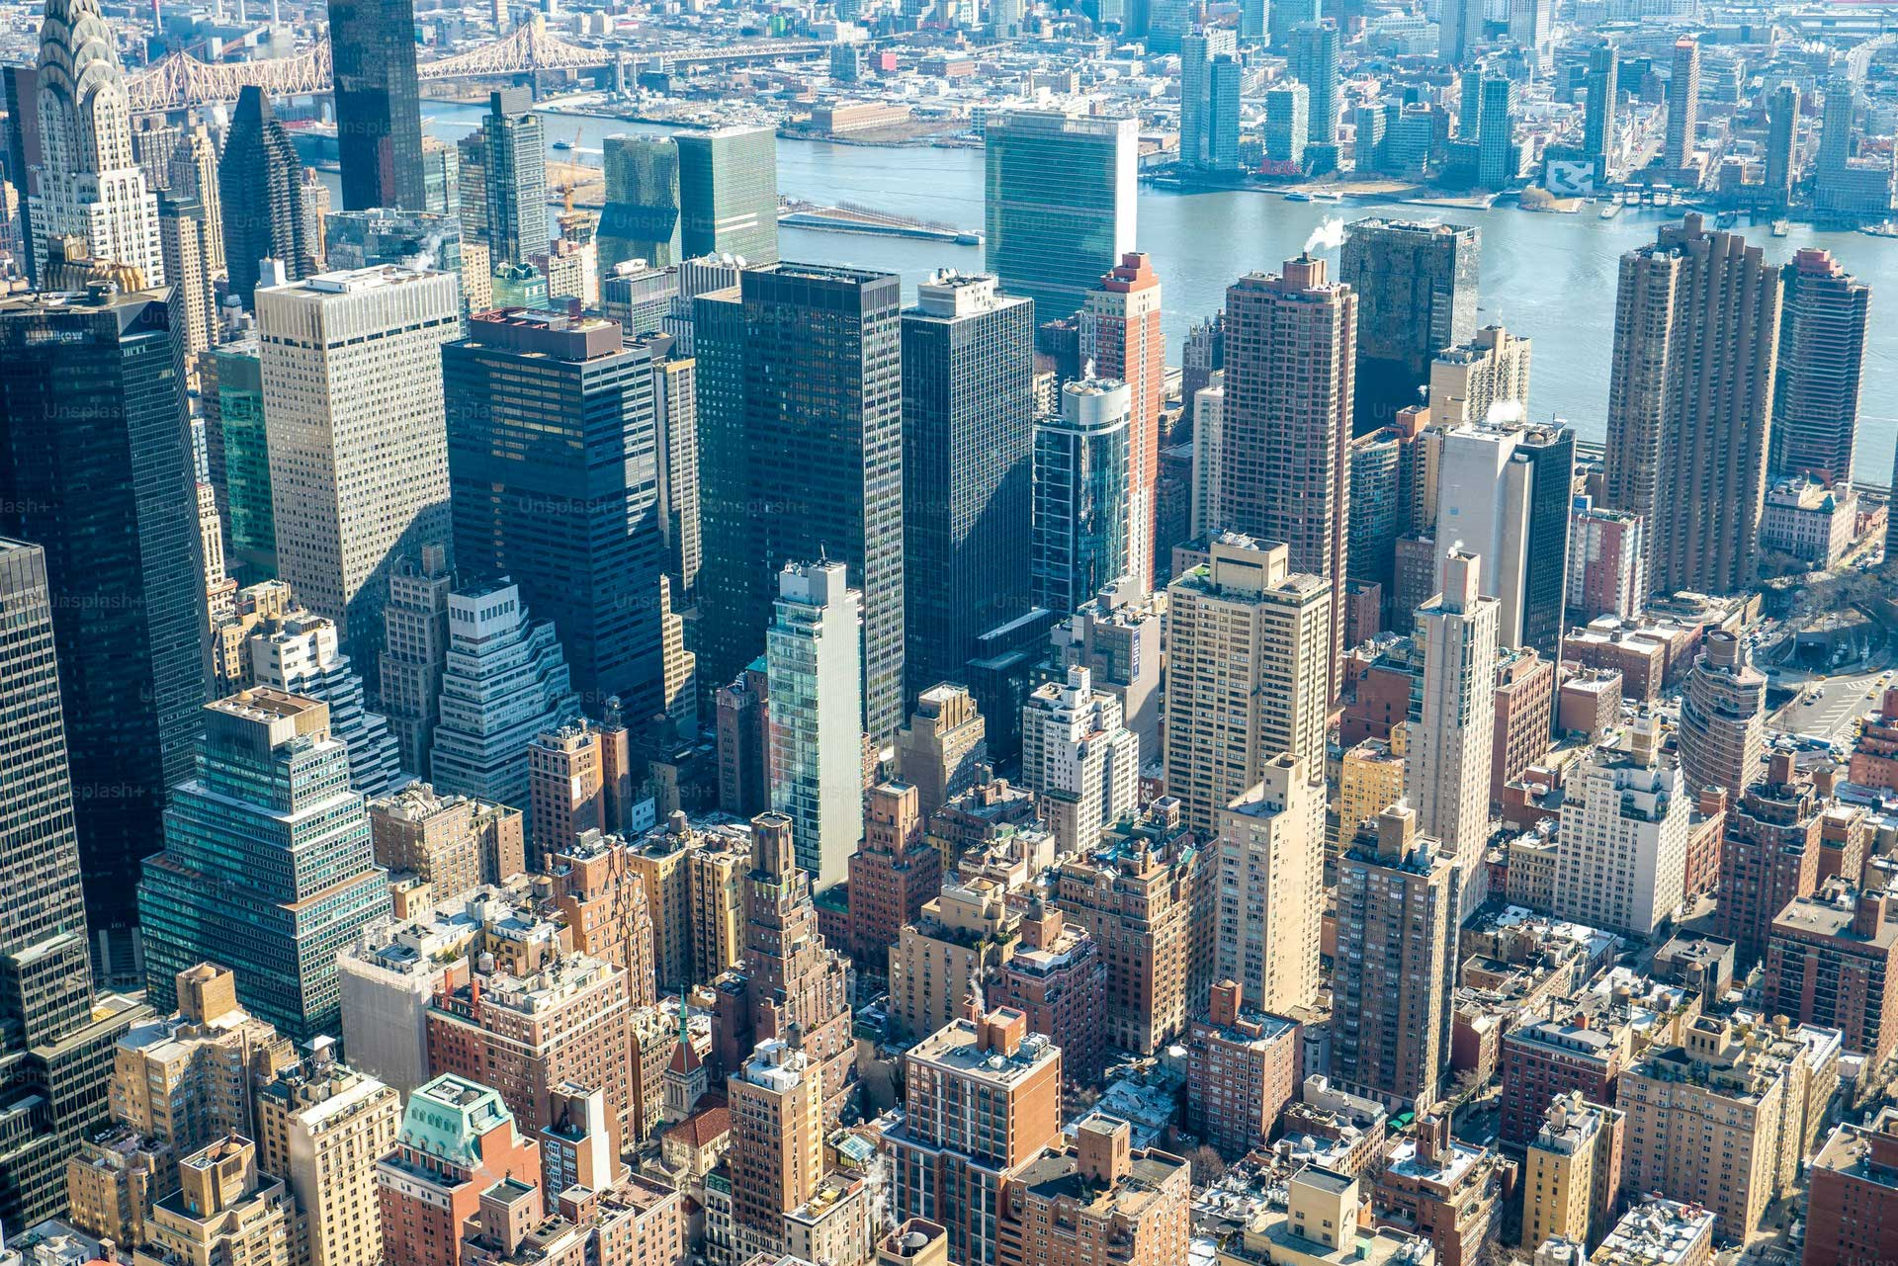

New York

| New York | | |
| --- | --- | --- |
| New York City is a very big city in the United States. It is made up of five different areas called boroughs. The boroughs are the Bronx, Brooklyn, Manhattan, Queens, and Staten Island. New York City was settled in 1624 and became a city in 1898. It was named after James, Duke of York.  New York City is the biggest city in the United States. Over 8 million people live there. New York City is also a very important place for business. It has a lot of businesses and makes a lot of money.  New York City is a very popular place to visit. There are many museums, parks, and other interesting places to see. The Museum of the City of New York has a lot of cool things to see, like a dollhouse and a collection of postcards. New York City is a very exciting place to live and visit! | | |

| Reading Summary | | |
| --- | --- | --- |
| * New York City is a big city in the United States that is made up of five different areas called boroughs. * New York City is the biggest city in the United States and has over 8 million people living there. * New York City is a popular place to visit because it has many museums, parks, and other interesting places to see. | | |

Vocabulary

| Term | Definition | | Example Sentence | |
| --- | --- | --- | --- | --- |
| settled (verb) | To make a place where people live and build homes. | | The pioneers settled in the valley and built their houses there. | |
| boroughs (noun) | Large areas of a city that are like smaller cities within the bigger city. | | New York City has five boroughs, each with its own unique character. | |
| collection (noun) | A group of things that are gathered together. | | The museum has a collection of dinosaur bones. | |
| postcards (noun) | Small cards with pictures on one side and space for writing on the other side. | | My grandma sends me postcards from her travels. | |
| exciting (adjective) | Making you feel happy and interested. | | The roller coaster ride was very exciting. | |

Multiple Choice Questions

| Question #1 | | Question #2 | | Question #3 | |
| --- | --- | --- | --- | --- | --- |
| How many boroughs are in New York City? | | What is the name of the museum that has a dollhouse and a collection of postcards? | | What is the name of the person that New York City was named after? | |
| A. One  B. Five  C. Ten  D. Twenty | | A. The Museum of the City of New York  B. The Metropolitan Museum of Art  C. The American Museum of Natural History  D. The Museum of Modern Art | | A. George Washington  B. Abraham Lincoln  C. James, Duke of York  D. Thomas Jefferson | |

Short Answer Questions

| Question #1 | What year did New York City become a city? | |
| --- | --- | --- |
| __________________________________________________________________________________________________________________________________________________________________________________________________________________________________________________________________________________________________________________________________________________________________________________ | | |
| Question #2 | Why is New York City an important place for business? | |
| __________________________________________________________________________________________________________________________________________________________________________________________________________________________________________________________________________________________________________________________________________________________________________________ | | |
| Question #3 | What are some interesting places to see in New York City? | |
| __________________________________________________________________________________________________________________________________________________________________________________________________________________________________________________________________________________________________________________________________________________________________________________ | | |

Open Ended Questions

| Question #1 | If you could visit any city in the world, which city would you choose and why? | |
| --- | --- | --- |
| __________________________________________________________________________________________________________________________________________________________________________________________________________________________________________________________________________________________________________________________________________________________________________________ | | |
| Question #2 | Think about your own town or city. What are some things that make it special or unique? | |
| __________________________________________________________________________________________________________________________________________________________________________________________________________________________________________________________________________________________________________________________________________________________________________________ | | |
| Question #3 | What are some things that you like to do in your free time? How are these activities similar to or different from the things people do in New York City? | |
| __________________________________________________________________________________________________________________________________________________________________________________________________________________________________________________________________________________________________________________________________________________________________________________ | | |

*This* [*Diffit*](https://www.google.com/url?q=https://web.diffit.me&sa=D&source=editors&ust=1718218821469671&usg=AOvVaw1fq6LVzYVp43ZNWhm6ip32)*resource was created by Philipp Varga*