**Arbeitsblatt für Tablets „POTENZEN“**

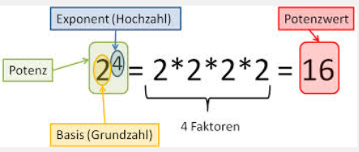24 = 2 ∙ 2 ∙ 2 ∙ 2 = 16

(-2) 4 = (-2) ∙ (-2) ∙ (-2) ∙ (-2) = + 16

-2 4 = **-** 2 ∙ 2 ∙ 2 ∙ 2 = **-** 16

= = 0,0625

2,56 ∙ 10³ = 2560

|  |  |  |  |
| --- | --- | --- | --- |
| **Thema** | **Link** | **QR-Code** | **erledigt** |
| **Learning Apps ☺ 😐 ☹** | | | |
| 1. Potenzen (Zuordnung) | <http://learningapps.org/1385075> |  |  |
| 1. Potenzen (Millionenshow) | <http://learningapps.org/473302> |  |  |
| 1. 2er Potenzen (Zahlenstrahl) | <http://learningapps.org/124415> |  |  |
| 1. 10er Potenzen (Zahlen ordnen) | <http://learningapps.org/26068> |  |  |
| 1. Potenzen der Größe nach ordnen (negative Zahlen) | <http://learningapps.org/1109904> |  |  |
| 1. Potenzen mit negativen Zahlen  Puzzle) | <http://learningapps.org/1109917> |  |  |
| **Realmath.de** | | | |
| 1. Potenzrechnung (Unterscheide zwei Arten!) | <http://www.realmath.de/Neues/Klasse7/ganzzahl/rechnemitpo01.html> |  |  |
| 1. Potenzen verbinden (Ganze Zahlen) | <http://www.realmath.de/Neues/Klasse7/ganzzahl/rechnemitpo.html> |  |  |

|  |  |  |  |  |  |  |  |  |  |  |  |  |  |  |  |  |  |  |  |  |  |  |  |  |  |  |  |  |  |  |  |
| --- | --- | --- | --- | --- | --- | --- | --- | --- | --- | --- | --- | --- | --- | --- | --- | --- | --- | --- | --- | --- | --- | --- | --- | --- | --- | --- | --- | --- | --- | --- | --- |
| **Zweierpotenzen (2er Potenzen)**   |  |  | | --- | --- | | 1² = 1 ∙ 1 = 1 | 11² = 11 ∙ 11 = 121 | | 2² = 2 ∙ 2 = 4 | 12² = | | 3² = | 13² = | | 4² = | 14² = | | 5² = | 15² = | | 6² = | 16² = | | 7² = | 17² = | | 8² = | 18² = | | 9² = | 19² = | | 10² = | 20² = | | **Potenzen mit negativer Basis (Grundzahl)**   |  | | --- | | (-2)1 = (-2) = - 2 | | (-2)² = (-2) ∙ (-2) = +4 | | (-2)3 = (-2) ∙ (-2) ∙ (-2) = - 8 | | (-2)4 = | | (-2)5 = | | (-2)6 = | | (-2)7 = | | (-2)8 = | | (-2)9 = | | (-2)10 = | |

**Zehnerpotenzen (10er Potenzen)**

|  |
| --- |
| 10 = 10 = 101 |
| 100 = 10 ∙ 10 = 102 |
| 1000 = 10 ∙ 10 ∙ 10 = 103 |
| 10 000 = 10 ∙ 10 ∙ 10 ∙ 10 = 104 |
| 100 000 = |
| 1 000 000 = |
| 10 000 000 = |
| 100 000 000 = |
| 1 000 000 000 = |

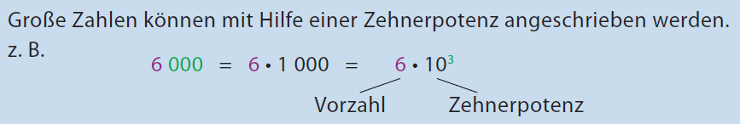

**Schreibe mit Vorzahl und Zehnerpotenz! Schreibe als natürliche Zahl!**

|  |  |
| --- | --- |
| 4 000 = 4 ∙ 1000 = | 5 ∙ 102 = 5 ∙ 100 = 500 |
| 30 000 = | 8 ∙ 104 = |
| 9 000 000 = | 2 ∙ 105 = |